**Rotary District 7600 Rotary Youth Leadership Awards**

**Important Dates:**

* October 15th deadline to email Leslie Bryant at [leslie.bryant@peninsulaymca.org](mailto:leslie.bryant@peninsulaymca.org) the number of delegates your club will be sponsoring. This is very important so that the committee can plan accordingly.
* December 15, 2018 completed delegate forms and payment will be due. Make checks payable to “RYLA 7600”
* February 16 – 18, 2018 RYLA will take place President’s Day Weekend

Saturday 9:00 a.m. – Monday 1:30 p.m.

**Cost: $250 Per Delegate**

**ROTARY YOUTH LEADERSHIP AWARDS (RYLA)** is a weekend leadership program for young adults, ages 15-18. It is designed for young adults with proven leadership ability and a commitment to community service.

Through RYLA, delegates can:

* Develop their leadership skills and character
* Gain exposure to a variety of issues and people
* Meet active community leaders
* Learn valuable information and career skills

All the while, they will also have fun, build friendships, and create memories that will last a lifetime.

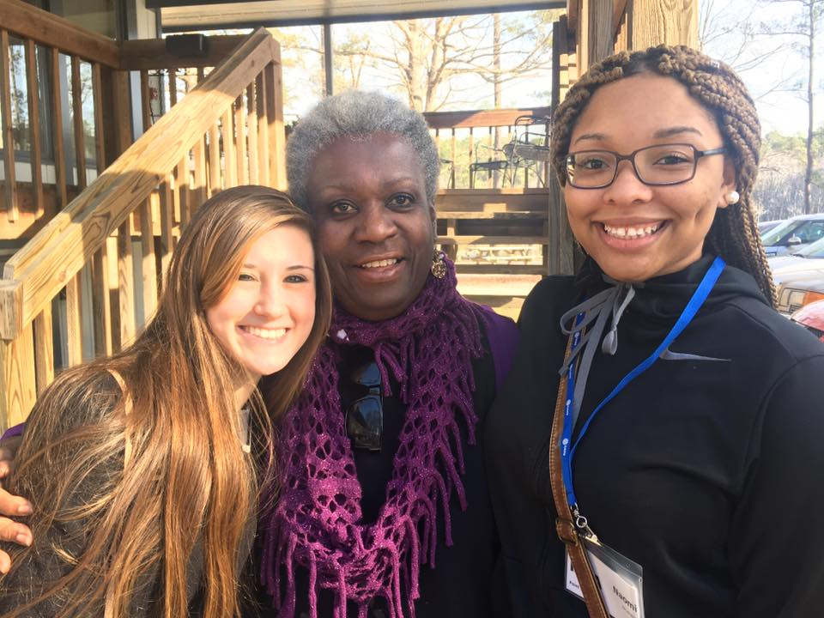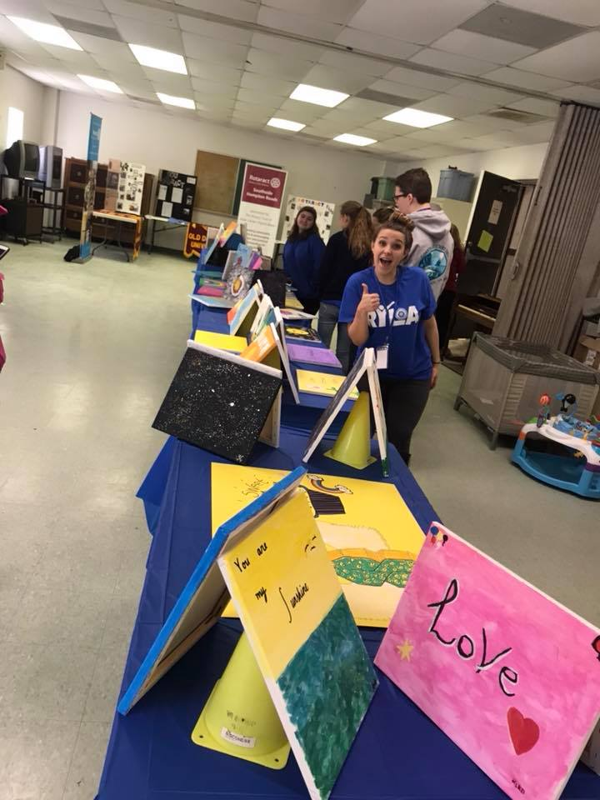

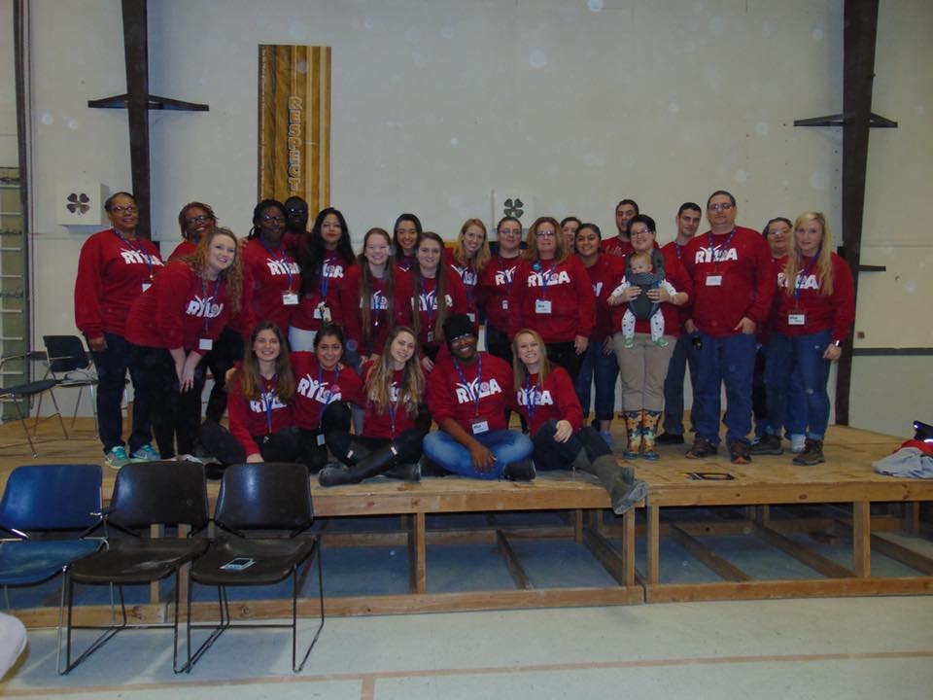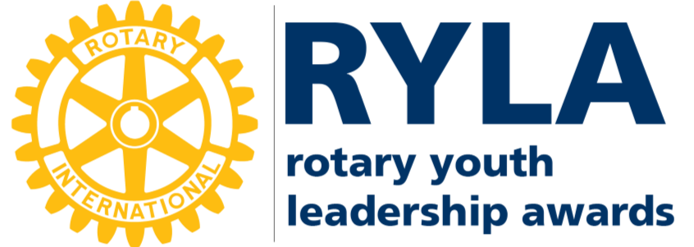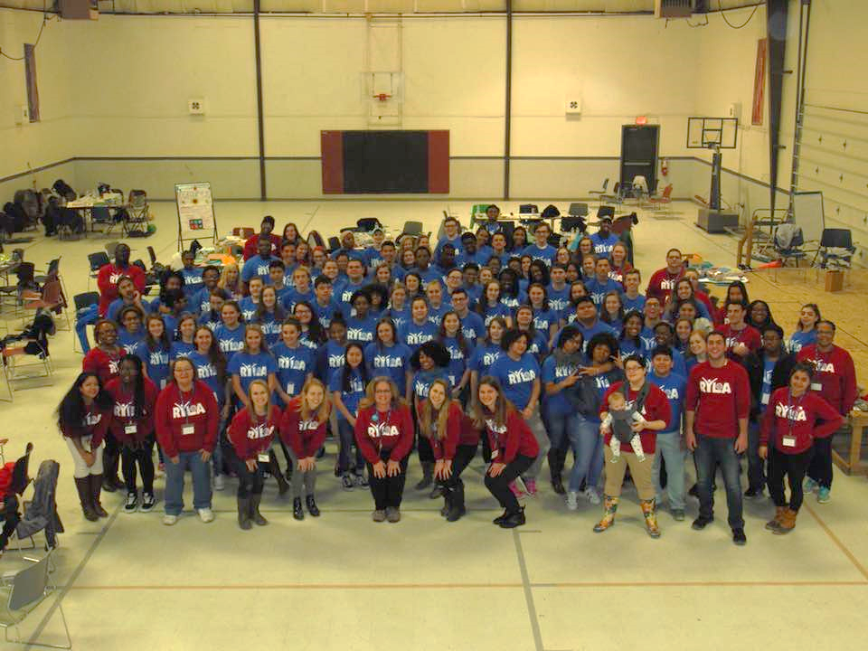

**Amazing Rotaract members from across our District come and serve**

**as Group Leaders RYLA weekend.**

**A chance to LEAD**

**RYLA Event Location:**

Airfield 4-H Center

15189 Airfield Road

Wakefield, VA 23888

**District RYLA Chair:**

Leslie Bryant

[Leslie.bryant@peninsulaymca.org](mailto:Leslie.bryant@peninsulaymca.org)

757-223-7925 ext. 207

**ROTARY YOUTH LEADERSHIP AWARDS**